**SET UP MULTI AGENT**

* Require to install:
  + Java 11
  + Login to agent, have internet connection.

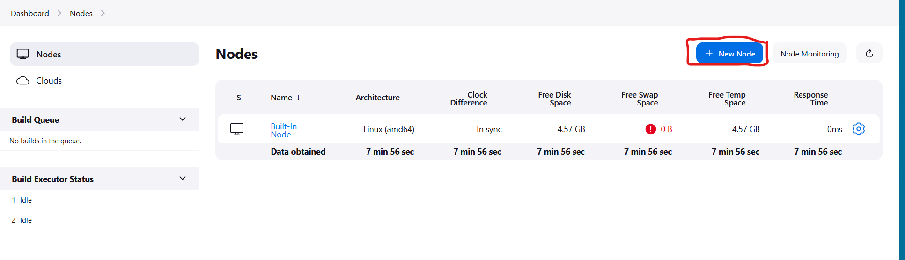

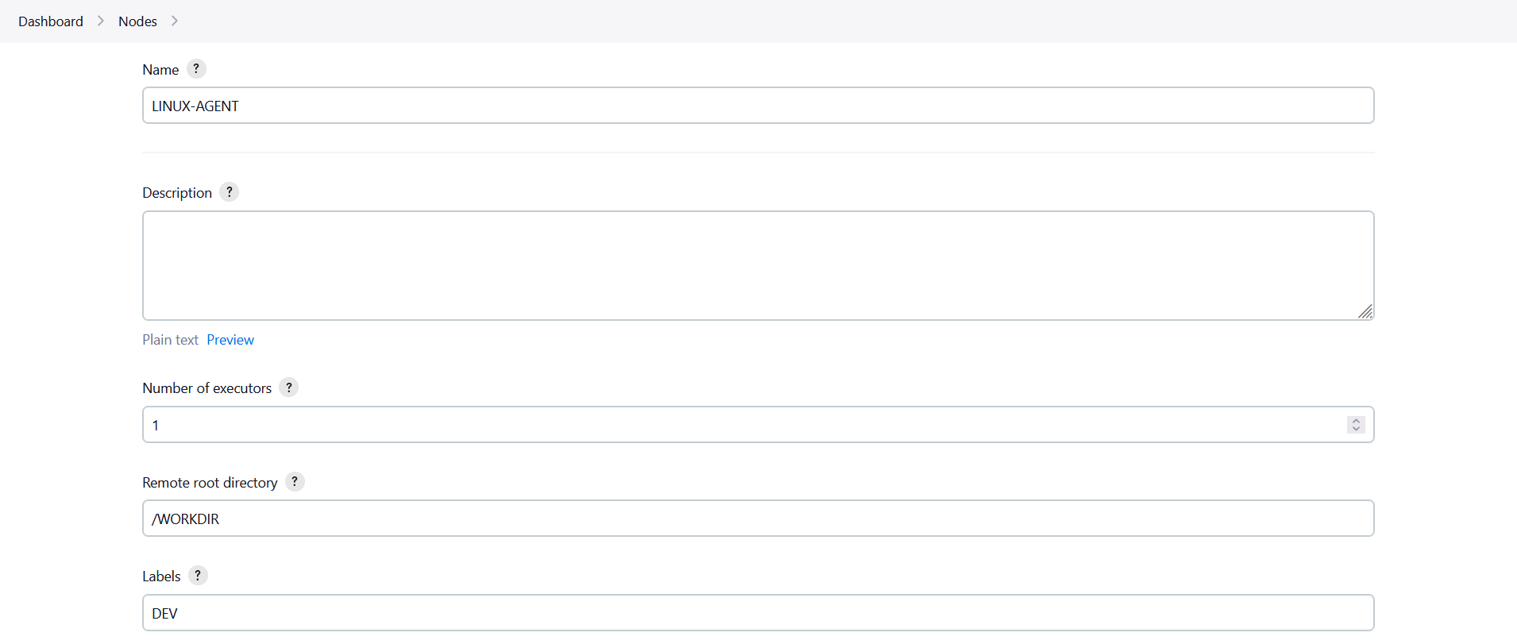

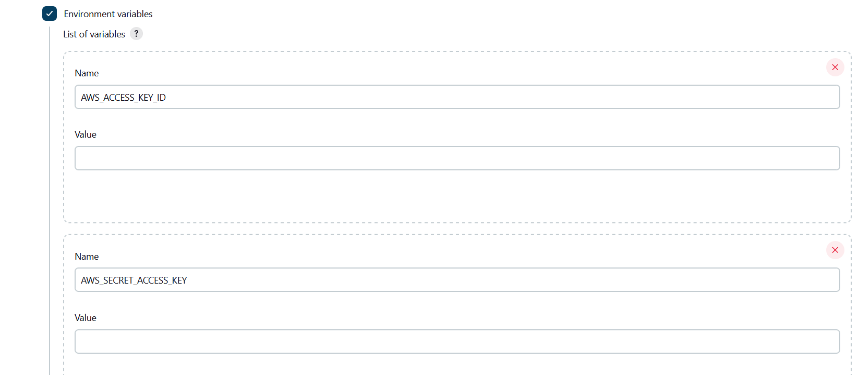

* Install java 11: “sudo apt install openjdk-11-jre-headless”

